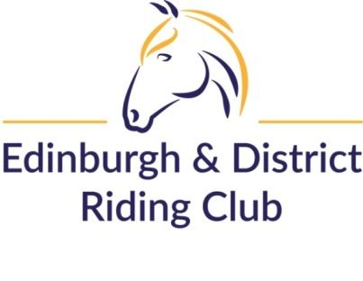

Rider Camp, Hosted by EDRC - 18th & 19th May 2024 – Open to ALL (over 18’s). Supportive, confidence building camp!
To be held at Lindores Cross Country, Braeside of Lindores, Newburgh, Fife, KY14 6HU by kind permission of Richard R. Black & Son.
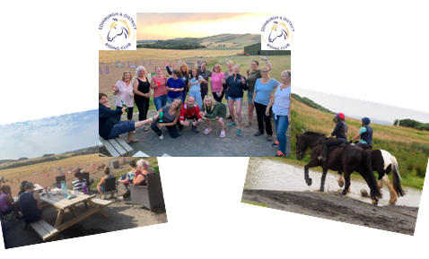
A total of 4 ridden sessions (mix of flatwork, polework, jumping and cross country schooling or hacking) from our amazing instructors Liz Daniels UKCC2, Rachel Maclean BHSAI and Carol Stanley BHSII APC.
Non ridden sessions including horse weigh-in and feed advice from Baileys, quiz, and more!
All for just £160 per horse and rider (individual days available at £80pp).
2 lessons per day, from a choice of flatwork, poles / gridwork, jumping, working hunter and cross country. Rider also have access the hacking routes around Lindores estate.
EDRC members have Fri and Sat night stabling included, non-members have day stabling and Sat night stabling included (Fri night can be added at a cost of £15 (book on club entries)).
All breakfast and lunches included – dinners are either BYO, takeaway or pub!
Accommodation On-site camping or space for your horsebox / caravan also included in price (electric hook-up available at £5 per day), or Lindores Tipi Tents (book direct with Lindores – equestrian@lindores.co.uk) at £10/bed per night, or Limited spaces available in West Lodge – Lindores luxury lodge @£75pppn (book direct with Anne Paxton at anne.marsden255@btinternet.com) – use of the hot tub after a long day’s horse riding!
Timing – lessons will start from 9am Saturday 18th May and aim to finish by 4pm on Sunday 19th May.
Bookings – can be made via www.clubentries.com/edinrc . To book for the FULL weekend please just enter both days, to book for one day only just enter that day. For individual days, book that day only.

