Jump Practice Day  The Fife Riding Club Showground – Glenrothes  SUNDAY 21 APRIL 2024 | 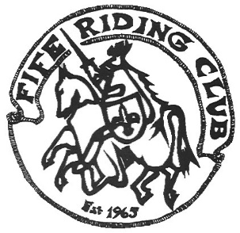

Class |  | Heights
Class 1 | Micro Stakes | Maximum height 40cm.Cross poles.  (Juniors, if any, may be assisted)
Class 2 | Beginners | Maximum height 45cm. Mainly cross poles
Class 3 | Minimus | Height 50-55cm.Some small spreads  Fillers to side.
Class 4 | Nursery Novice | Height 60-65cm.
Class 5 | Novice | Height 70-75cm.
Class 6 | Intermediate | Height 80-85cm
Class 7 | Small Open | Height 90-95cm
Class 8 | Open | Height 100+

Open to non-members & juniors. Juniors must be accompanied by a responsible adult.

All classes single phase

Rosettes to 6th place

Entries to be made via clubentries.com. Closing date for online entries will be Friday 19 April

If time permits, entries MAY be taken on the day subject to a £1 per class surcharge.

Dress code – smart casual or show dress. Riders must wear safety helmets which comply with current BRC rulebook. Padded whips to be carried. Back protectors are advised but optional.
The competition will be run under current BRC Rules (copy available on FRC website)
See next page for important information

Non-members are required to have their own personal accident and public liability insurance (e.g. BHS Gold membership)

STANDARD DISCLAIMER
Save for the death or personal injury caused by the negligence of the organisers or anyone for whom they are in law responsible, neither the organisers of any event to which these rules apply, nor any agent, employee or representative of these bodies accepts liability for any accident, loss, injury to horses, owners, riders, spectators, land or any other person or property whatsoever, whether caused by their negligence, breach of contract or in any other way whatsoever

