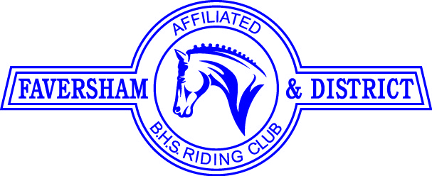

BBQ & FUN QUIZ
on June 13th
at The Alma, Painters Forstal ME13 0DU
at 7.00 pm

Come and join us at The Alma for a sizzling Summer BBQ - a chance to catch up with FDRC friends and have a good natter and eat delicious food on a warm Summer evening. All under cover.
There will be a Quiz and if you want to take part you can tackle it by yourself or with a partner or even a team or not do it at all! The choice is yours - Prize for the winner(s)
Cost will be £14.00 per head -- to book please go to https://clubentries.com/favershamrc/ or you can contact Anne on 07979 432818 or at v.a.ball@outlook.com and then pay by BACs or cheque.

