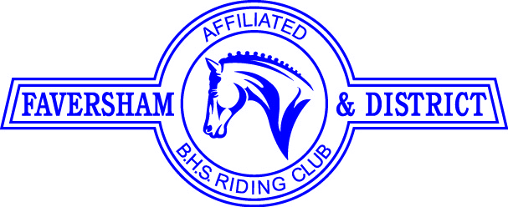

FIT BIT TALK & DEMO by VICKI WISE , on Sat April 25th
at 11.00 am at 2 Little Kennaways, Stalisfield Road, Faversham ME13 0AB
by kind permission of Patrick & Corinne Murphy
Vicki Wise, LANTRA Accredited Horse Fit Bit Consultant and FDRC Member, will discuss the importance of bit and bridle fit to improve a horse’s comfort, biomechanics and their welfare.
Horse Fit Bit believe that the correct fit of both a bit and bridle are equally as important as saddle fit and should not be left to trial and error. Vicki has been qualified and working as a freelance Horse Bit Fit Consultant for over a year now and has already performed consultations for over 170 horses across the South East.
Vicki will give a talk with slides and then we will move outside for a practical demonstration.
During the talk, Vicki will cover:
- Bit and bridle fit to improve horse’s comfort and biomechanics.
- Dispelling some traditional myths surrounding bitting.
- Looking at some of the latest research on bitting and bridle fit.
- Understanding anatomy in relation to bit and bridle fit.
- Looking at behavioural and physical issues arising from poor bitting and bridle fit to improve horse’s welfare.
ENTRY FEE - £5.00 for FDRC Members & £10.00 for Non-Members including light refreshments Payable on the day or via https://clubentries.com/favershamrc/

